Practical-2

Aim: - 1. Create a student table (Roll no, Name, Dept,) and write the queries to carry out the following operation.

SQL> Create a table student (rollno int, name varchar (50), dept varchar (10), marks int);

2. Now run the desc student to check the structure of the table

SQL> desc student;

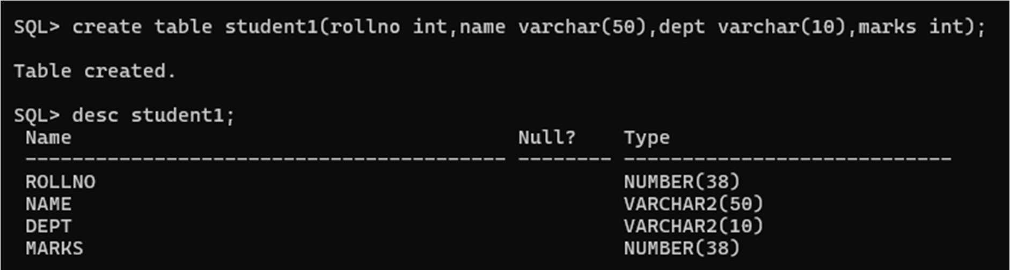

3. Insert the 20 Rows in the table.

SQL>

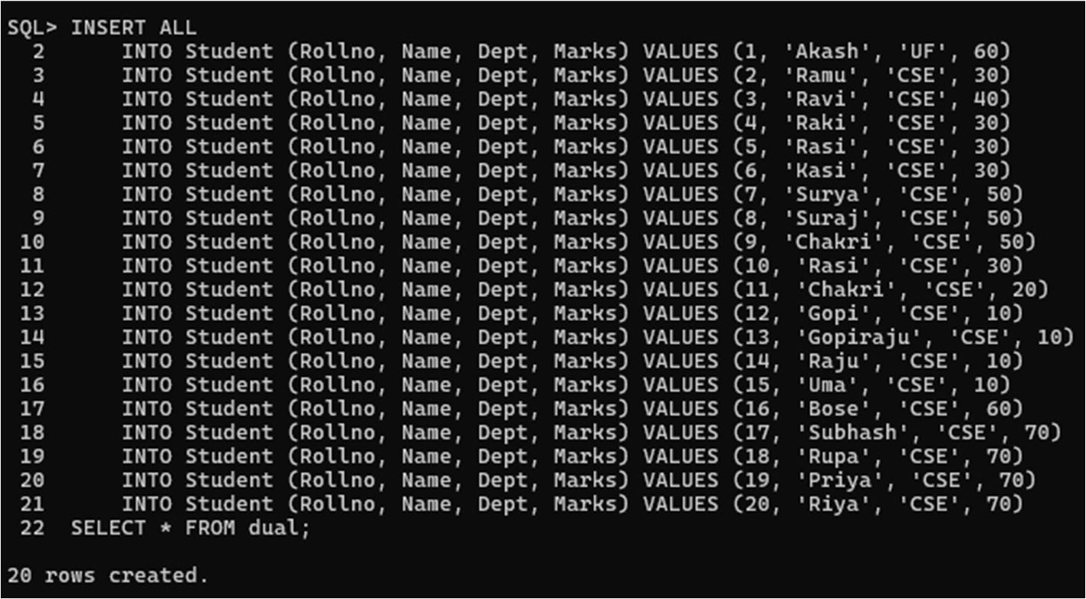

4. view the complete the table.

SQL> select \* from student;

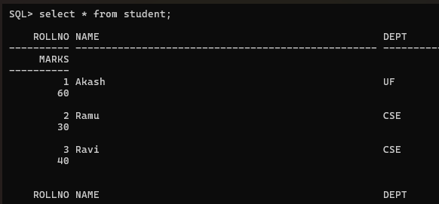

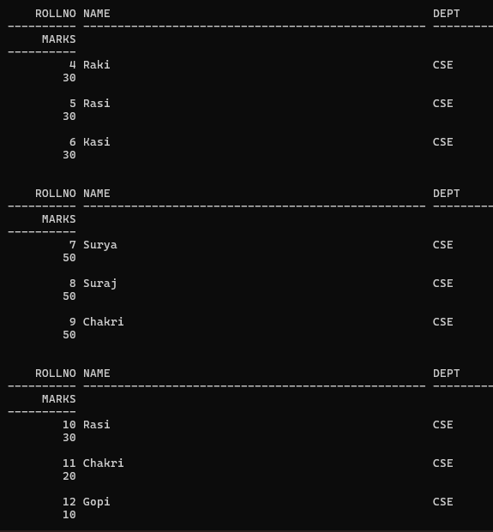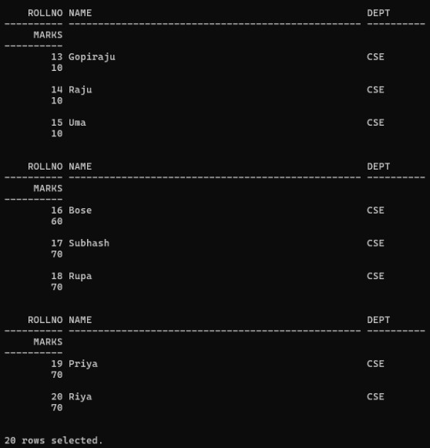

5. Delete 5 rows from the table.

SQL> delete from student where marks=30;

